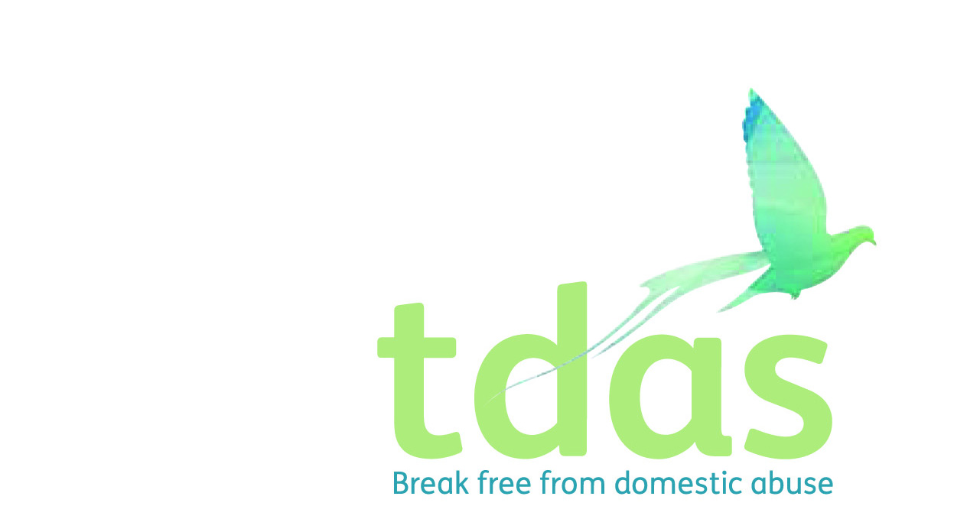

Job Title: IDVA (High/Medium Risk)

Salary: £24,012

Benefits: A generous package including 33 days holiday per year inclusive of bank holidays (FTE), extra holidays, for long service, Employee pension scheme with 3% employer contribution (after 3 months of employment), Cycle2work Scheme, Life assurance benefit, 365 days a year Employee Assistance Programme

Location: Manchester

Closing Date: Wednesday 30th June 2021

Date of Interview: Thursday 8th July 2021

Start Date: ASAP

Hours: 37 hours per week

Contract end date: Fixed term until March 2023

Background

TDAS is an independent voluntary organisation which is affiliated to Women’s Aid Federation England. TDAS and has been operating since June 1990. TDAS is a company Limited by guarantee and a registered charity.

TDAS is the only specialist agency in Trafford to deliver both intervention and prevention services to adults and children and young people who are experiencing or have experienced domestic abuse.

Purpose of the role

To play an integral and active part in the community based IDVA and outreach support team. You will work as part of a skilled, multi-disciplinary staff team and must be approachable and highly motivated in supporting and encouraging people experiencing domestic violence/abuse to make informed choices in order to determine their own future. You will ensure the provision of support and advocacy services to service users who are experiencing or have experienced Domestic Abuse. Assessing the risk a service user is in and delivering a service appropriate to the level of risk.

Main Duties

* Provide a person centred, outreach service to adults accessing the IDVA service. This could be via face to face, telephone or other digital means
* To liaise with MARAC agencies to promote TDAS service offer and encourage referrals/self referrals.
* To decide on the most appropriate method of offering support to service users in accordance with MARAC policy and within the resources available
* To assess the risk the service user is in using the SafeLives DASH Risk Indicator Checklist and ensure that the delivery of the IDVA service is appropriate to this level of risk and to notify the Senior IDVA of any risks identified.
* Participate in the Multi-Agency Risk Assessment Conference framework: refer clients to, attend and participate in meetings and follow up actions agreed in the MARAC

To apply for this position it is essential that you have a NNEB/NVQ level 3 or equivalent qualification in social care or education.

You must also have minimum of 2 years experience of working with young people in crisis and knowledge and understanding of the effects of domestic abuse on adults, children and young people. You must be able to assess risk, support plan and deliver services. It is essential that you have an up to date knowledge of Child Protection and Safeguarding.

This post is subject to an enhanced DBS.

**Applicants with minimum qualifications and experience will only be considered. Due to the requirements of the role, we are requesting that female only applicants apply. Please do not send CVs, as they will not be processed.**

No agencies please.

For further information please contact [admin@tdas.org.uk](mailto:admin@tdas.org.uk) Tel: 0161 872 7368

An application pack is available to download from [www.tdas.org.uk](http://www.tdas.org.uk)