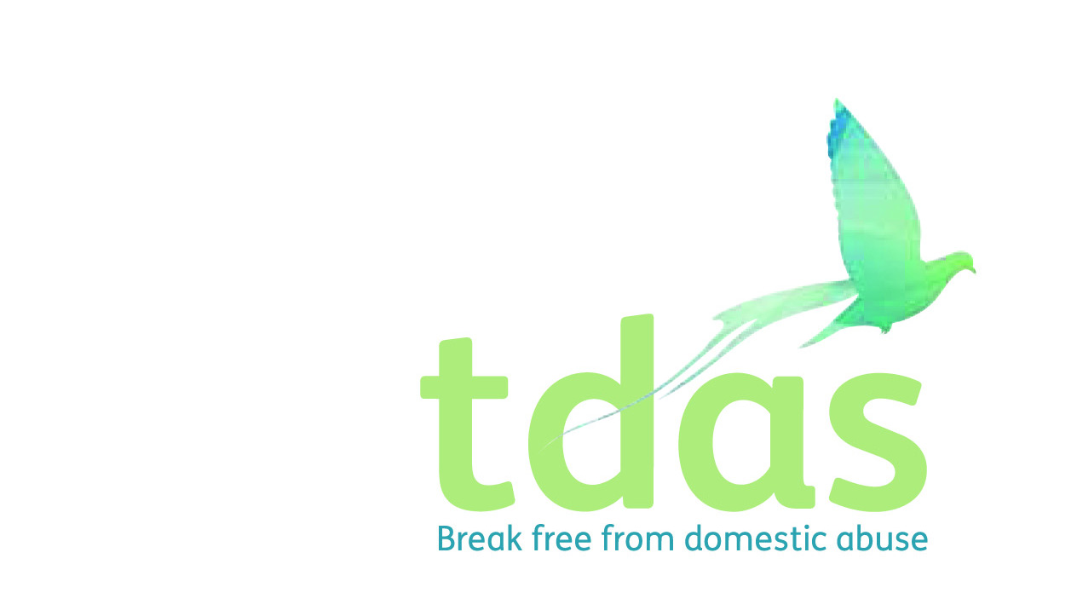

Job Title: Domestic Abuse Advisor

Salary: £24,012

Location: Trafford

Benefits: A generous package including 33 days holiday per year inclusive of bank holidays (FTE), extra holidays, for long service, Employee pension scheme with 3% employer contribution (after 3 months of employment), Cycle2work Scheme, Life assurance benefit, 365 days a year Employee Assistance Programme

Contract: Fixed term for 12 months from starting date

Closing Date: Monday 2nd August 2021

Date of Interview: Wednesday 9th August 2021

Hours: 37 hours per week (Mon-Fri)

**Background**

TDAS is an independent voluntary organisation which is affiliated to Women’s Aid Federation England. TDAS and has been operating since June 1990. TDAS is a company Limited by guarantee and a registered charity. TDAS is the only specialist agency in Trafford to deliver services to adults, children and young people who are experiencing or have experienced domestic abuse.

**Purpose of the role**

To provide a specialist trauma-informed support service for those adults who are residing in TDAS Accommodation, homeless/at risk of homelessness working with multiple agencies supporting their multiple needs. The Post holder will work collaboratively with partners to provide expert advice for women in refuge, temporary and supported accommodation and support women who have resettled in the community to maintain their tenancies and stay safe, preventing them from becoming homeless.

You will work as part of a skilled, multi-disciplinary staff team and must be approachable and highly motivated in supporting and encouraging each individual person experiencing domestic abuse to make choices in order to determine their own future.

**Main duties**

• Provide specialist trauma-informed 1-2-1 support for women in Refuge, Move on and Supported Accommodation across Trafford including both practical and emotional support and safety planning

• To provide move on support for families and individuals as they leave the accommodation service – this could be planned or unplanned.

• Develop partnerships with Local RSL's to increase accommodation capacity including specific provision for adults with disabilities and diverse communities

Support the delivery of Domestic Abuse Awareness Training for all housing and support staff throughout the partnership

• Delivery of TDAS True Colours; DA Programme for survivors of Domestic Abuse to enable them to break free, move on with their lives and break the cycle of abuse

To apply for this position you must have a minimum of two years experience of working with service users in a supported and enabling setting, knowledge and understanding of the effects and the impact of domestic abuse on adults, children and young people, including all relevant legislation and experience of working with individuals in a crisis situation, demonstrating strong crisis management, skills and ability to cope under pressure. It is essential that you have an up to date knowledge of Child Protection and Safeguarding.

This post is subject to an enhanced DBS.

For further information please contact Jade Powell or Olivia Jay [admin@tdas.org.uk](mailto:admin@tdas.org.uk) Tel: 0161 872 7368

An application pack is available to download from [www.tdas.org.uk](http://www.tdas.org.uk)