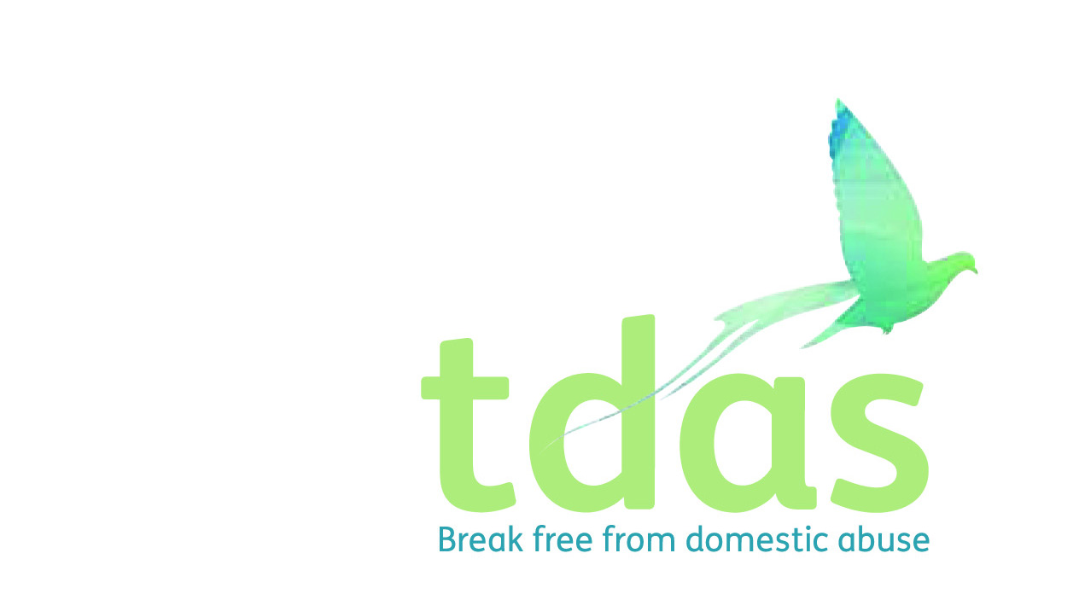

Job Title: Move On Domestic Abuse Advisor (MODAA)

Salary: £19,326.48 actual (FTE: £23,836)

Pension: Pension scheme entitlement after 3 months of employment

Location: Manchester

Closing Date: 24th February 2020 6pm

Date of Interview: Wednesday 4th March 2020

Preferable Start Date: April 2020

Hours: 30 hours per week

Contract end date: Fixed term until March 2021 with possibility to extend depending of further funding.

Background

TDAS is an independent voluntary organisation which is affiliated to Women’s Aid Federation England. TDAS and has been operating since June 1990. TDAS is a company Limited by guarantee and a registered charity. TDAS is the only specialist agency in Trafford to deliver services to men, women, children and young people who are experiencing or have experienced domestic abuse.

Purpose of the role

To provide a specialist trauma-informed support service for those women who are homeless/at risk of homelessness working with multiple agencies supporting their multiple needs. The Post holder will work collaboratively with partners to provide expert advice for women in refuge, temporary and supported accommodation and support women who have resettled in the community to maintain their tenancies and stay safe, preventing them from becoming homeless. Educating agencies involved with the women to ensure they receive the right response and are not re-traumatised is also a key part of the role.

Main duties

* Partnership with HOST (Trafford's homelessness & housing options service) to provide a place based support service for women who are presenting with housing needs as a result of domestic abuse.
* To be based at HOST twice a week offering drop in, pre-appointment service for women and to offer support to housing staff.
* Develop partnerships with Local RSL's to increase accommodation capacity including specific provision for women with disabilities and BAME
* Support the delivery of Domestic Abuse Awareness Training for all housing and support staff throughout the partnership

To apply for this position it is essential that you have a NNEB/NVQ level 3 or equivalent qualification in child care and education, social care or teaching. You must also have minimum of 2 years experience of working with children and young people in crisis and knowledge and understanding of the effects of domestic abuse on men, women, children and young people. You must be able to assess risk, support plan and deliver services. It is essential that you have an up to date knowledge of Child Protection and Safeguarding.

This post is subject to an enhanced DBS.

**Applicants with minimum qualifications and experience will only be considered. Due to the requirements of the role, we are requesting that female only applicants apply. Please do not send CVs, as they will not be processed.**

No agencies please.

For further information please contact Jade Powell [admin@tdas.org.uk](mailto:admin@tdas.org.uk) Tel: 0161 872 7368

An application pack is available to download from [www.tdas.org.uk](http://www.tdas.org.uk)