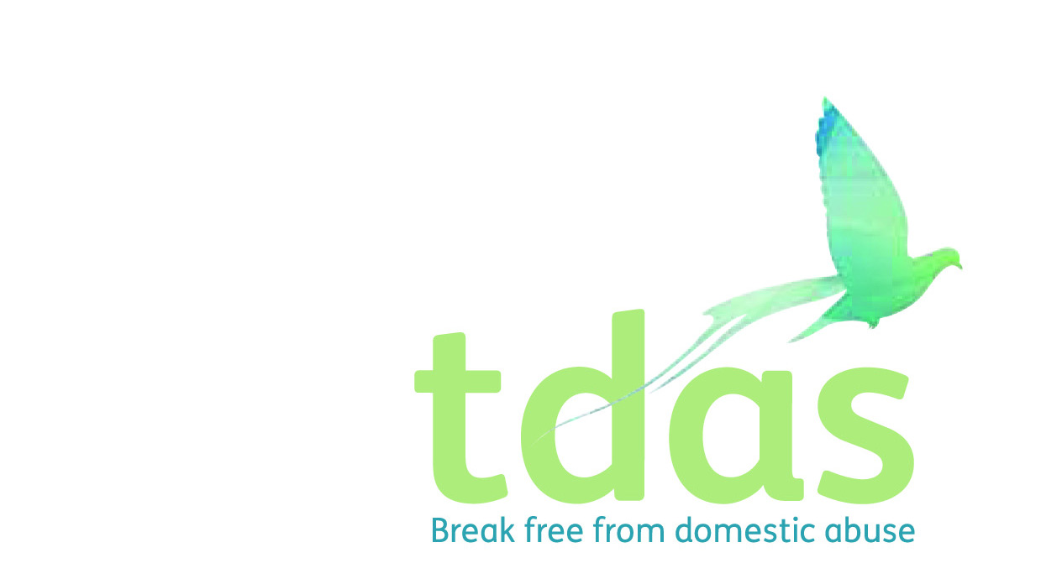

Job Title: Children and Young People’s Support Worker (Maternity Cover)

Salary/ Rate: £14, 513 actual per annum

Pension: Pension scheme entitlement after 3 months of employment

Location: Manchester

Closing Date: Monday 2nd December @ 6pm

Date of Interview: Tuesday 10th December or Thursday 12th December (date to be confirmed)

Preferable Start Date: ASAP

Hours: 22.5 hours per week

Contract end date: 31st August 2020

**Description:**

To deliver our specialist Children and Young Peoples project in the Community to a group of children who have or are currently are living with domestic abuse and suffering the traumatic effects of such. The CYP Support worker will provide 1 to 1 support to children in the local community and deliver specialist domestic abuse workshops and programmes in school and community settings.

**Main duties will include:**

* Provide 1-2-1 sessions in the community.
* Deliver TDAS R’Space© programmes for CYP who have or are living in a domestic abuse household.
* Deliver TDAS SOSN© programmes for CYP identified as in need.
* Keep daily recordings which are factual, accurate and up to date. Partnership and multi agency liaison work.
* To be aware of, implement and keep up to date with Child Protection/Safeguarding procedures in accordance with the organisation.
* Provide a welcoming, safe, stimulating and inclusive environment in which children and young people can be supported, enjoy themselves, develop their full potential and meet the requirements of Every Child Matters and current legislation.

To apply for this position it is essential that you have a NNEB/NVQ level 3 or equivalent qualification in child care and education, social care or teaching. You must also have minimum of 2 years experience of working with children and young people in crisis and knowledge and understanding of the effects of domestic abuse on men, women, children and young people. You must be able to assess risk, support plan and deliver services. It is essential that you have an up to date knowledge of Child Protection and Safeguarding.

This post is subject to an enhanced DBS.

**Applicants with minimum qualifications and experience will only be considered. Due to the requirements of the role, we are requesting that female only applicants apply. Please do not send CVs, as they will not be processed.**

No agencies please.

For further information please contact Jade Powell [admin@tdas.org.uk](mailto:admin@tdas.org.uk) Tel: 0161 872 7368

An application pack is available to download from [www.tdas.org.uk](http://www.tdas.org.uk)