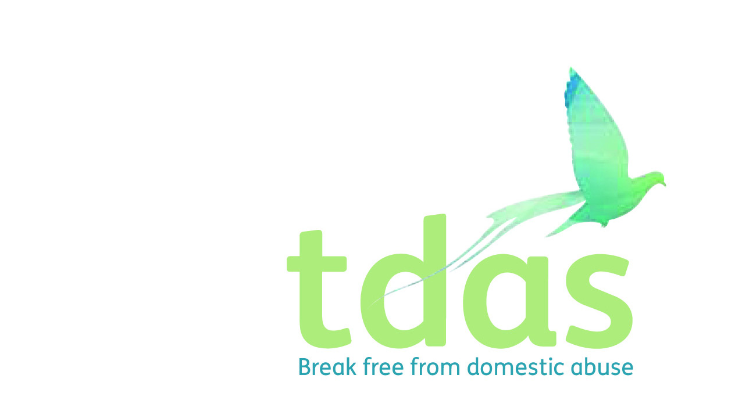

Job Title: Young Persons IDVA

Salary: £14,000 actual

Pension: Pension scheme entitlement after 3 months of employment

Location: Salford

Closing Date: Tuesday 25th August

Date of Interview: Tuesday 1st September

Preferable Start Date: ASAP

Hours: 21 hours per week

Contract end date: 31st March 2022

Background

Trafford Domestic Abuse Services (TDAS) is an independent voluntary organisation that has been operating since June 1990, is a Company Limited by guarantee and a registered charity. TDAS is the only specialist agency in Trafford who deliver services to women, men, children and young people who are experiencing or have experienced domestic abuse. We are funded for our services through various funding streams and are in the process of looking for further areas of funding to enable us to extend the services we provide in the borough of Trafford.

Purpose of the role

This role will offer emotional support to young people who are victims of domestic abuse. Additionally the role will tackle engagement from young people who attend sexual health clinics, encouraging referrals in relation to young people who are in sexually abusive relationships. This role will be to encourage the use of DASH in sexual health assessments with young people. To train up staff and offer quarterly training sessions in relation to identifying signs of domestic abuse for professionals and support social workers on best practice.

Main Duties

* Access, organise and deliver the appropriate services to meet the needs of the young people in abusive relationships
* Undertake the appropriate risk assessments to measure level of risk i.e DASH
* To provide advice and support on best practice to social workers who are working with families experiencing domestic abuse
* Undertake initial assessments on young people and compile individual support and safety plans based on recognised frameworks within agreed timescales.
* Deliver Domestic Abuse Awareness trainings to professionals
* Work closely with sexual health clinics, encouraging the use of DASH in sexual health assessments
* To Keep daily recordings which are factual, accurate and up to date
* Identify and Liaise with the local agencies, professionals and forums which would need to be involved in identifying the cases of young people experiencing serious harm from interpersonal violence and abuse, and ensure that they are linked into an agreed care/referral pathway that includes both safeguarding and MARAC.
* Engage local agencies, professionals and forums in developing such a care pathway.

To apply for this position it is essential that you have a Safe Lives IDVA qualifications and a minimum Level 3 1. NNEB/NVQ level 3 or equivalent qualification in Child care and education, Social Care or Teaching . You must also have minimum of 1 years experience of working with children and young people or young adults in crisis and knowledge and understanding of the effects of domestic abuse on men, women, children and young people. You must be able to assess risk, support plan and deliver services. It is essential that you have an up to date knowledge of Child Protection and Safeguarding.

This post is subject to an enhanced DBS.

**Applicants with minimum qualifications and experience will only be considered. Due to the requirements of the role, we are requesting that female only applicants apply. Please do not send CVs, as they will not be processed.**

No agencies please.

For further information please contact Amy Moss [amy.moss@tdas.org.uk](mailto:amy.moss@tdas.org.uk) Tel: 0161 872 7368

An application pack is available to download from [www.tdas.org.uk](http://www.tdas.org.uk)