**Trafford Domestic Abuse Services Telephone: 0161 872 7368.   
Return completed form by email to admin@tdas.org.uk**

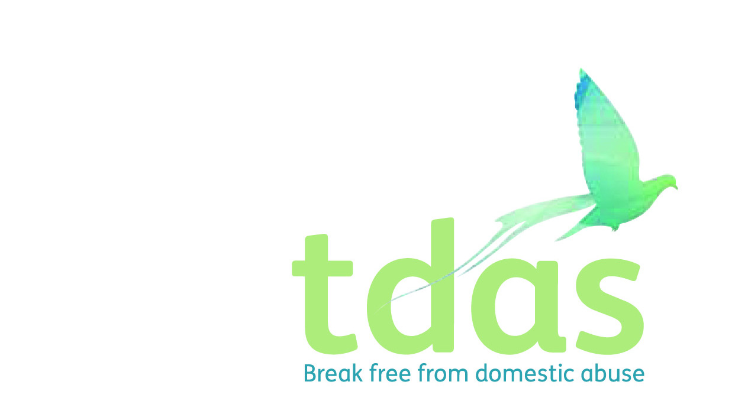

**Services Referral Form**

1-2-1 Community Services we offer:

**Floating Support:**

Primarily supporting women and children to maintain their accommodation. Specialist domestic abuse advisors deliver emotional and resettlement support to victims of domestic abuse providing targeted support for up to 6 months and then further individual support can be provided by our trained volunteers.

**Outreach Service:**

This service offers support and advice on a broader range and is not focused on accommodation. At these sessions an experienced DA advisor will offer information, advice and support to people who have experienced or are experiencing domestic abuse.

Women’s Group Programs we offer:

**True Colours Program:**

This is a 6-week information and support program built around the realities and effects of domestic abuse for victims to gain a deeper understanding of the dynamics of domestic abuse, to identify unhealthy relationships and to learn strategies to protect themselves in the future.

**Back to me program:**

This is a one 3-hour personal development course focusing on how to take care of yourself and move forward after experiencing domestic abuse. This program focuses on communication skills, confidence building and assertiveness etc.

Women’s Groups:

**Healing hearts:**

This is a group that meets every 3 weeks to empower women to make positive changes in their lives. It is a safe space for women who have experienced similar circumstances to support aid and recovery and partake in arts and crafts and relaxation activities.

|  |  |  |  |  |  |  |  |  |  |  |  |  |  |
| --- | --- | --- | --- | --- | --- | --- | --- | --- | --- | --- | --- | --- | --- |
| **Referrers Contact Details** *(If self-referral please leave blank)* | | | | | | | | | | | | | |
| Referred by:  (Your full name, address, contact details) | |  | | | | | | | | | | | | |
| **Client Personal Contact Details** | | | | | | | | | | | | | | |
| Date of Referral: | |  | | | | | | | | | | | | |
| Client name | |  | | | | | DOB | | |  | | | | |
| Current address  Postcode | |  | | | | | Sexuality | | |  | | | | |
| Ethnicity | | |  | | | | |
| Accommodation type | | |  | | | | |
| Contact no. | |  | | | | | Safe to call and leave a voicemail? | | |  | | | | |
| Does client live with perpetrator? | |  | | | | | Does client have any children? If so, how many | | |  | | | | |
| Is it safe to contact client at their address? | |  | | | | | Safe to attend a 1-2-1 drop-in? | | |  | | | | |
| Any communication/access to information needs?(*e.g. learning difficulties, large print, braille, audio, interpreter required etc*) | | | | | | |  | | | | | | | |
| Any disabilities?  (*Physical, hearing, vision, mental health*) | | | | | | |  | | | | | | | |
| **Please tick which service you are referring to:** *(You can refer to more than one service)* | | | | | | | | | | | | | | |
| Floating Support 🞏 | Outreach Service 🞏 | | | True Colours program 🞏 | | | | Back to me program 🞏 | | | | Women’s group 🞏 | | |
| **= Perpetrator’s Details (If known)** | | | | | | | | | | | | | | |
| Name | |  | | | | | D.O.B | | |  | | | | |
| Address (if different) | |  | | | | | Ethnicity | | |  | | | | |
| Relationship to victim (married, sibling, parent etc) | |  | | | | | Relationship status (e.g. together, separated) | | |  | | | | |
| **Safety & Wellbeing** | | | | | | | | | | | | | | |
| **Types of abuse experienced:** | | **Please give brief summary:** | | | | | | | | | | | | |
| Physical | |  | | | | | | | | | | | | |
| Emotional | |  | | | | | | | | | | | | |
| Psychological | |  | | | | | | | | | | | | |
| Financial | |  | | | | | | | | | | | | |
| Sexual | |  | | | | | | | | | | | | |
| **Safety issues: Please X in the relevant boxes** | | | | | | | | | | | | | | |
| Issues regarding homelessness | |  | BAME needs e.g. language/ dishonour based abuse/FGM | |  | Learning disability | | |  | | Substance misuse - alcohol | |  | |
| Living with the perpetrator | |  | Children: contact /CSS involvement | |  | Physical ill-health | | |  | | Substance misuse - drugs | |  | |
| Risk from perpetrator/ other people | |  | Pregnant | |  | Mental health needs | | |  | | Self harm / attempted suicide | |  |
| LGBT needs | |  | Child offence/ conviction | |  | History of violence / arson | | |  | | Gang involvement | |  | |
| Housing/ Resettlement needs? | |  | | | | | | | | | | | | |
| Anything else? | |  | | | | | | | | | | | | |
| **Reason for Referral**  Relevant and up to date information about current support needs. Last incident/how long domestic abuse has been going on/police involvement and any outcomes/legal issues. Also include details if recorded yes to the above safety issues e.g. a physical disability that requires wheelchair use, mental health needs that are supported by CMHT etc | | | | | | | | | | | | | | |
|  | | | | | | | | | | | | | | |