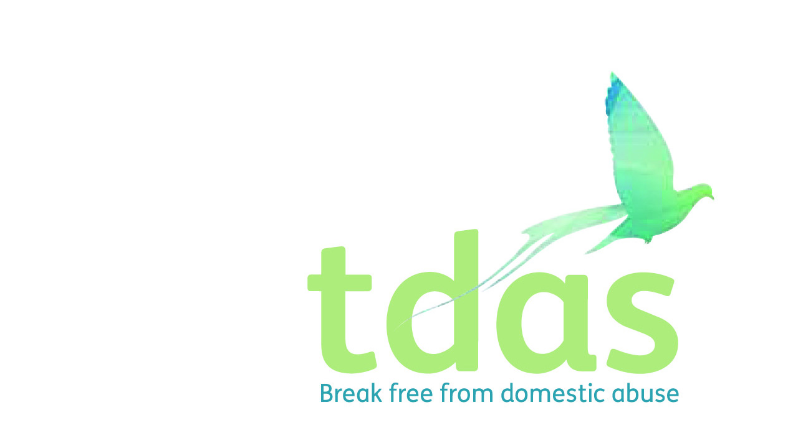

Job Title: Domestic Abuse Advisor

Salary: £14,601.89 (£24,012 FTE)

Location: Trafford

Benefits: A generous package including 33 days holiday per year inclusive of bank holidays (FTE), extra holidays, for long service, Employee pension scheme with 3% employer contribution (after 3 months of employment), Cycle2work Scheme, Life assurance benefit, 365 days a year Employee Assistance Programme

Hours: 22.5 hours per week

Contract: Fixed term for 12 months from start date

Closing Date: Monday 2nd August 2021

Date of Interview: Wednesday 11th August 2021*

*(Please inform us when submitting your application form if you cannot make this date.)

Background

TDAS is an independent voluntary organisation which is affiliated to Women’s Aid Federation England. TDAS and has been operating since June 1990. TDAS is a company Limited by guarantee and a registered charity. TDAS is the only specialist agency in Trafford to deliver services to men, women, children and young people who are experiencing or have experienced domestic abuse.

Purpose of the role

To provide a trauma-informed support service for those women who are living in TDAS refuges or other accommodations. Working collaboratively with partners to provide practical advice and emotional support for adults in refuge, temporary and supported accommodation and to ultimately support them with their resettlement into the community.

You will work as part of a skilled, multi-disciplinary staff team and must be approachable and highly motivated in supporting and encouraging each individual person experiencing domestic abuse to make choices in order to determine their own future.

Main duties

• To provide a specialist trauma-informed 1-2-1 support for women in Refuge, Move on and Supported Accommodation across Trafford including practical and emotional support, and safety planning

• To network and liaise with all relevant agencies regarding the emotional, developmental and practical needs of adults, children and young people for whom TDAS is providing a service

• To welcome adults into the accommodation services, providing guidance and induction to the service and answering queries and concerns.

• To ensure all areas of TDAS properties are safe/clean, and all repairs/breakages are reported in a timely manner and any associated repairs are undertaken within defined timescales

To apply for this position you must have a minimum of two years experience of working with service users in a supported and enabling setting, knowledge and understanding of the effects and the impact of domestic abuse on adults, children and young people, including all relevant legislation and experience of working with individuals in a crisis situation, demonstrating strong crisis management, skills and ability to cope under pressure. It is essential that you have an up to date knowledge of Child Protection and Safeguarding.

This post is subject to an enhanced DBS.

For further information please contact Jade Powell or Olivia Jay [admin@tdas.org.uk](mailto:admin@tdas.org.uk) Tel: 0161 872 7368

An application pack is available to download from [www.tdas.org.uk](http://www.tdas.org.uk)