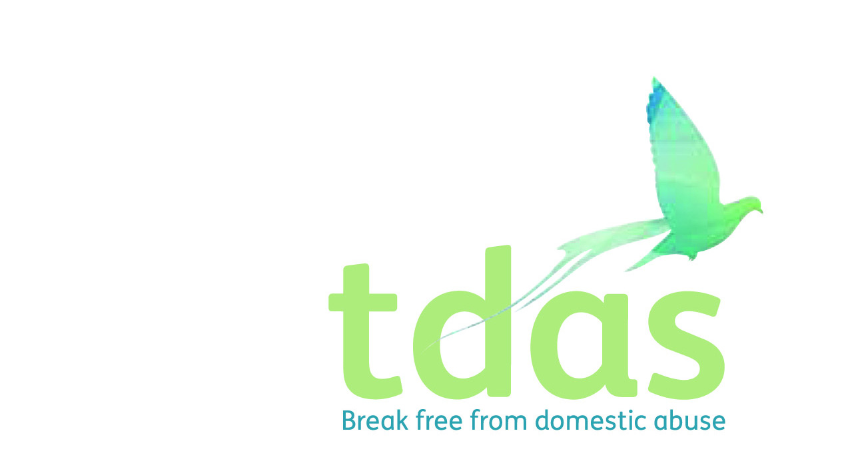

Job Title: Community Team Leader

Salary: £19, 243.16 (actual)

Pension: Entitlement after 3 months of employment

Location: Trafford

Closing Date: Thursday 21st May 2020

Date of Interview: Tuesday 26th May 2020

Preferable Start Date: ASAP

Hours: 28 hours

Contract Length: 18 months with possible extension

**Background**

TDAS is an independent voluntary organisation which is affiliated to Women’s Aid Federation England. TDAS and has been operating since June 1990. TDAS is a company Limited by guarantee and a registered charity. TDAS is the only specialist agency in Trafford to deliver services to adults, children and young people who are experiencing or have experienced domestic abuse.

**Purpose of the role**

To lead and supervise the Community team in the day to day running of TDAS Community Service. To ensure the provisions of a flexible range of services for adults who have suffered domestic abuse living in the Trafford community. To support and line manage a team of IDVAs and Outreach DA Advisors to provide a high quality frontline service to victims of domestic abuse that delivers a service in particular to those highest risk. To be the lead in crisis situations and provide advice and guidance on child protection issues and information sharing concerns. To consult with all service users and stakeholders, in order to evaluate and improve the Community service to meet the needs of adults effected by domestic abuse.

**Main duties**

• Provide Induction, Management, supervision and direction to the Community team.

• Manage and coordinate the referral processes and support provision for High and Medium Risk Victims of domestic abuse

• Ensure that there is a consistent delivery of services to survivors, including risk assessment, safety planning, referrals to other agencies and MARACs by allocating and monitoring work across the team.

• Ensure that risk assessment and risk management procedures are followed at all times, prioritising those most at risk.

• Support and co-supervise the volunteers and students allocated to the Community Service.

To apply for this position it is essential that you have a NNEB/NVQ level 3 or equivalent qualification in social care NNEB/NVQ level 3 or equivalent qualification in Social care , a Minimum of two years’ experience of working with adults in a domestic abuse setting and a Minimum of two years managing/leading a team. You must be able to assess risk, support plan and deliver services. It is essential that you have an up to date knowledge of Safeguarding.

This post is subject to an enhanced DBS.

**Applicants with minimum qualifications and experience will only be considered. Due to the requirements of the role, we are requesting that female only applicants apply. Please do not send CVs, as they will not be processed.**

No agencies please.

For further information please contact Jade Powell [admin@tdas.org.uk](mailto:admin@tdas.org.uk) Tel: 0161 872 7368

An application pack is available to download from [www.tdas.org.uk](http://www.tdas.org.uk)