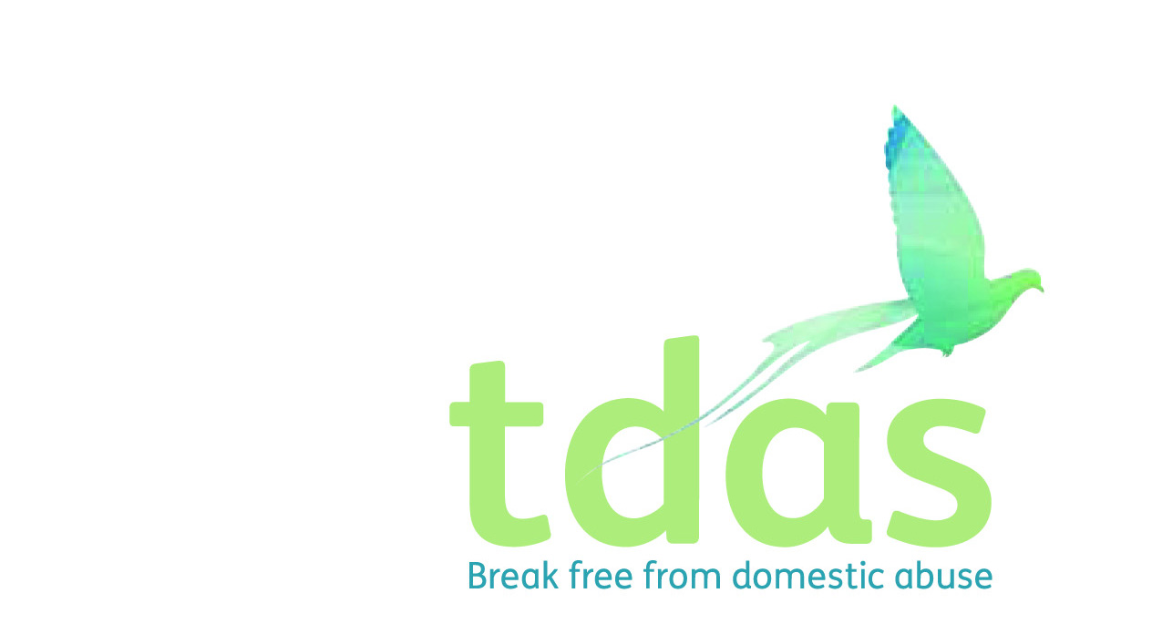

Job Title: Domestic Abuse Advisor

Salary: Actual £19,087 - £21,073 (£23,541-£25,991 FTE) Fixed term until March 2022 with possibility to extend depending of further funding.

Location: Manchester

Closing Date: Sunday 13th June 2021

Date of Interview: Monday 21st June 2021

Hours: 30 hours per week

Background

TDAS is an independent voluntary organisation which is affiliated to Women’s Aid Federation England. TDAS and has been operating since June 1990. TDAS is a company Limited by guarantee and a registered charity. TDAS is the only specialist agency in Trafford to deliver services to men, women, children and young people who are experiencing or have experienced domestic abuse.

Purpose of the role

To play an integral and active part in the community based outreach support and community projects within Trafford. Working as part of a skilled, multi-disciplinary staff team and must be approachable and highly motivated in supporting and encouraging people experiencing domestic violence/abuse to make informed choices in order to determine their own future

To apply for this position you must have a minimum of two years experience of working with service users in a supported and enabling setting, knowledge and understanding of the effects and the impact of domestic abuse on adults, children and young people, including all relevant legislation and experience of working with individuals in a crisis situation, demonstrating strong crisis management, skills and ability to cope under pressure. It is essential that you have an up to date knowledge of Child Protection and Safeguarding.

This post is subject to an enhanced DBS.

For further information please contact Jade Powell [admin@tdas.org.uk](mailto:admin@tdas.org.uk) Tel: 0161 872 7368

An application pack is available to download from [www.tdas.org.uk](http://www.tdas.org.uk)