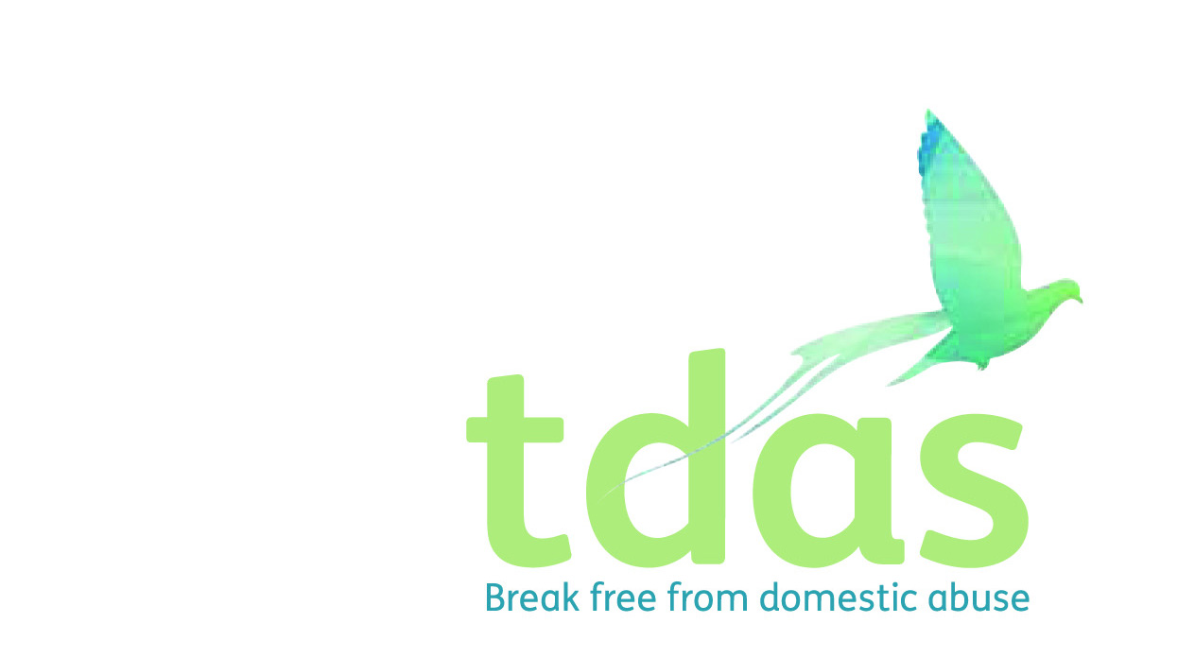

|  |  |
| --- | --- |
| **Title:** | Children and Young People’s Group Facilitator |
| **Area:** | CYP Service |
| **Reporting to:** | CYP Team Leader  *All paid members of staff are accountable to the CEO, and ultimately the Trustees of TDAS* |
| **Place of work:** | Trafford |
| **Hours of Work** | 22.5 hours per week |
| **Salary/scale:** | £14,566 - £16,082 (£23,953 - £26,446 FTE) |
| **Benefits:** | A generous package including 33 days holiday per year inclusive of bank holidays (FTE), extra holidays, for long service, Employee pension scheme with employer contribution (after 3 months of employment), Cycle2work Scheme, Life assurance benefit, 365 days a year Employee Assistance Programme |
| **Closing Date** | Sunday 5th June 2022 |
| **Date of Interview \*\*** | Thursday 9th and Friday 10th June 2022 |
| **Start Date** | ASAP |
| **Contract Length** | 3 Years |
|  | \*\***If you cannot make the date please inform us when submitting your application** |

**Background**

Trafford Domestic Abuse Services (TDAS) is a Quality accredited, registered charity offering support to individuals and families who are affected by domestic abuse since 1990. We support families who live/work in the Trafford area and also provide IDVA and Children and Young People (CYP) support services in Salford. We provide both intervention and prevention services and work in partnership with other voluntary organisations to support families across Greater Manchester.

**TDAS Values**

Innovative: introduce new ideas, are creative and foreword thinking.

Collaborative: work in partnership with key stakeholders to enable people to achieve a defined & common purpose

Openness: create an open culture, provide transparent reporting, good fundraising and governance.

Person centred: provide coordinated, personalized and enabling services to everyone

Empowering: empower our service users to become stronger, more confident, being aware of their rights and privileges and live a more meaningful and fulfilling life.

**Purpose of the role**

To deliver our specialist Children and Young People’s project in the Community to a group of children who have or currently are living with domestic abuse and suffering the traumatic effects of such. The CYP group facilitator will provide a trauma informed support service to support children in the local community and deliver specialist domestic abuse workshops and programmes in school and community settings. Additionally they will liaise with schools across the city to our services and deliver training around domestic abuse to professionals.

**Application Criteria and Process**

To apply for this position it is essential that you have NNEB/NVQ level 3 or equivalent qualification in Domestic Abuse, Social Care, Teaching and experience of delivering group programmes or training/presenting.

You must also have minimum of 12 months experience of working with children in social care settings and knowledge and understanding of the effects of domestic abuse on adults, children and young people. You must be able to assess risk, support plan and deliver services. It is essential that you have an up to date knowledge of Child Protection and Safeguarding.

This post is subject to an enhanced DBS.

**Applicants with minimum qualifications and experience will only be considered. Due to the requirements of the role, we are requesting that female only applicants apply. Please do not send CVs, as they will not be processed.**

No agencies please.

For further information please contact [admin@tdas.org.uk](mailto:admin@tdas.org.uk) Tel: 0161 872 7368

An application pack is available to download from [www.tdas.org.uk](http://www.tdas.org.uk)