**Trafford Domestic Abuse Services Telephone: 0161 872 7368.   
Return completed form by email to admin@tdas.org.uk**

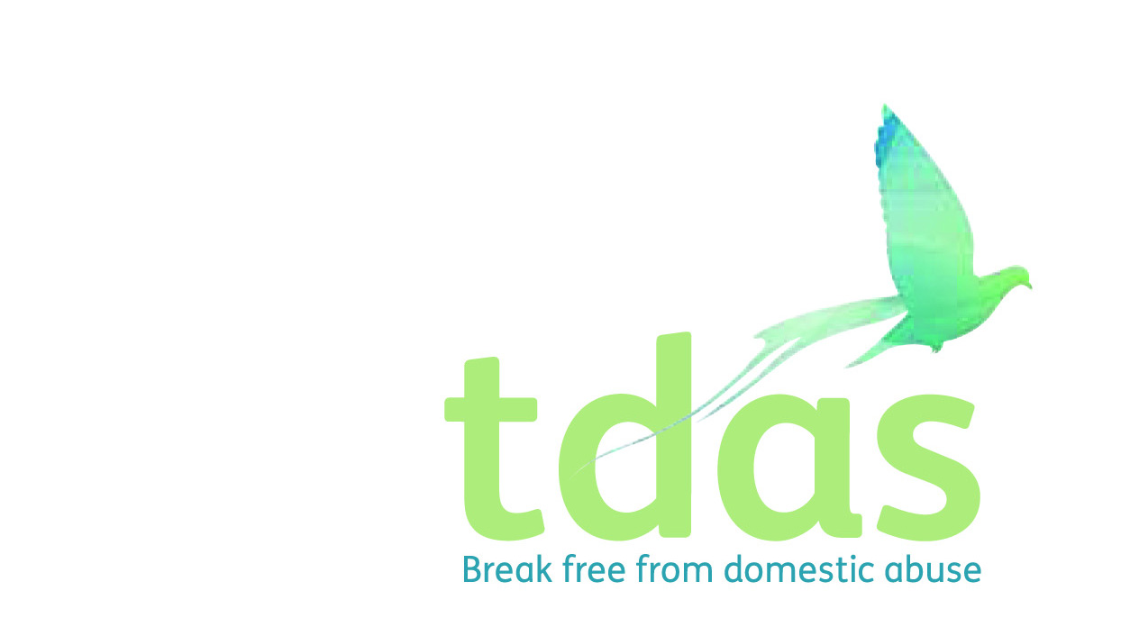

**Adult Services Referral Form**

**Community Services:**

Domestic Abuse Surgery

This service offers 1-2-1 practical advice and emotional support around domestic abuse. The client can access up to 6 sessions with a DA advisor face to face or over the phone. The DA Surgery runs every Monday and Friday and is an appointment only service for medium to standard risk clients.

Community outreach

This service offers 1-2-1 longer term support to clients who have additional support and/or complex needs. Offering information, advice and support to people who have experienced or are experiencing domestic abuse on a longer term basis, through individual support and safety planning.

**Group Programs:**

True Colours Program:

This is a 6-week information and support program built around the realities and effects of domestic abuse for victims to gain a deeper understanding of the dynamics of domestic abuse, to identify unhealthy relationships and to learn strategies to protect themselves in the future.

Back to me program:

This is a 3-hour personal development course focusing on how to take care of yourself and move forward after experiencing domestic abuse. This program focuses on communication skills, confidence building and assertiveness.

**IDVA Support:**

Our specialist team of Independent Domestic Violence Advocates (IDVAs) work with adults in the Trafford area aged 16 and over, who are identified as being at high and increased risk of domestic abuse. Referrals to this service come through the MARAC process.

**Homelessness Service:**

Our homelessness Move On DA Adviser offers support to clients who are at risk of homelessness as a result of domestic abuse or those who are already homeless, living in temporary accommodation, B&B’s or similar because of experiencing domestic abuse.

|  |  |  |  |  |  |  |  |  |  |  |  |  |  |
| --- | --- | --- | --- | --- | --- | --- | --- | --- | --- | --- | --- | --- | --- |
| **Referrer’s Contact Details** *(If self-referral please leave blank)* | | | | | | | | | | | | | |
| Referred by:  (**Your full name, address, contact details**) | | |  | | | | | | | | | | | |
| **Client’s Personal Contact Details** | | | | | | | | | | | | | | |
| Date of Referral: | | |  | | | | | | | | | | | |
| Client name: | | |  | | | | | DOB: | |  | | | | |
| **Has the client consented to this referral?** | | |  | | | | | | | | | | | |
| Current address:  Postcode: | | |  | | | | | Contact number: | |  | | | | |
| Safe to call and leave a voicemail? | |  | | | | |
| Safe to attend a 1-2-1 drop-in? | |  | | | | |
| Does client live with perpetrator? | | |  | | | | | Does client have any children? If so, how many | |  | | | | |
| Is it safe to contact client at their address? | | |  | | | | | Is the client pregnant? | |  | | | | |
| Any communication/access to information needs?(*e.g. learning difficulties, large print, braille, audio, interpreter required etc*) | | | | | | | |  | | | | | | |
| Any disabilities? (*Physical, hearing, vision, mental health*) | | | | | | | |  | | | | | | |
| **Please tick which service you are referring to:** *(You can refer to more than one service)* | | | | | | | | | | | | | | |
|  | Domestic Abuse Surgery / Community outreach 🞏 | | | True Colours program 🞏 | | | | Back to me program 🞏 | | | | Homelessness Service 🞏 | | |
| **= Perpetrator’s Details (If known)** | | | | | | | | | | | | | | |
| Name | |  | | | | | | D.O.B | |  | | | | |
| Address (if different) | |  | | | | | | Ethnicity | |  | | | | |
| Relationship to victim (married, sibling, parent etc) | |  | | | | | | Relationship status (e.g. together, separated) | |  | | | | |
| **Safety & Wellbeing** | | | | | | | | | | | | | | |
| **Types of abuse experienced:** | | **Please give brief summary:** | | | | | | | | | | | | |
| Physical | |  | | | | | | | | | | | | |
| Emotional | |  | | | | | | | | | | | | |
| Psychological | |  | | | | | | | | | | | | |
| Financial | |  | | | | | | | | | | | | |
| Sexual | |  | | | | | | | | | | | | |
| **Safety issues: Please write X in the relevant boxes** | | | | | | | | | | | | | | |
| Issues regarding homelessness | |  | | | BAME needs e.g. language/ dishonour based abuse/FGM |  | Learning disability | |  | | Substance misuse - alcohol | |  |
| Living with the perpetrator | |  | | | Children: contact /CSS involvement |  | Physical ill-health | |  | | Substance misuse - drugs | |  |
| Risk from perpetrator/ other people | |  | | | Pregnant |  | Mental health needs | |  | | Self harm / attempted suicide | |  |
| LGBT needs | |  | | | Child offence/ conviction |  | History of violence / arson | |  | | Gang involvement | |  |
| Housing/ Resettlement needs? | |  | | | | | | | | | | | | |
| Anything else? | |  | | | | | | | | | | | | |
| **Reason for Referral**  Relevant and up to date information about current support needs. Last incident/how long domestic abuse has been going on/police involvement and any outcomes/legal issues. Also include details if recorded yes to the above safety issues e.g. a physical disability that requires wheelchair use, mental health needs that are supported by CMHT etc | | | | | | | | | | | | | | |
|  | | | | | | | | | | | | | | |