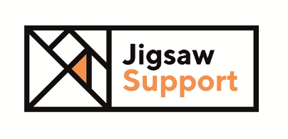
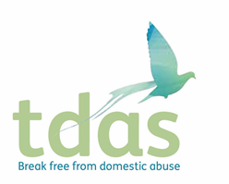

Female Advocate Educator

ADViSE (Assessing for Domestic Violence and Abuse in Sexual Health Environments)

Hours: 32, 35 and 37 hrs per week

Salary: £27,741 - £29,577

Posts: 6 Advocate Educators (AE), 1 Coordinator/AE, 1 Senior AE
Locations: Across Greater Manchester

We are looking for someone who is highly motivated to liaise closely with sexual health clinics, provide training for clinicians and offer emotional and practical support to patients who are affected by domestic abuse and/or sexual violence.

The successful applicant will have:
- Experience of working with victims and survivors of domestic abuse and/or sexual violence
- An understanding of the gendered nature of violence and abuse, and of the impact of multiple, intersecting oppressions (e.g. sexism, racism, homophobia, ableism, etc) and the consequent barriers to accessing support services
- Experience of promoting services and building strong working relationships with external organisations
- Experience of delivering training to a range of professionals
- An empathetic approach
- A full driving licence and access to transport.

Closing date: 9 am 16th August 2021

Interviews: 23rd & 24th August 2021 (by zoom video conferencing)

IF YOU ARE INTERESTED IN APPLYING PLEASE DOWNLOAD AN APPLICATION PACK (WITH JDs AND PS) AT https://www.tdas.org.uk/workwithus

Jigsaw Support, Manchester Women’s Aid, Trafford Domestic Abuse Services & Stockport Without Abuse are committed to Equal Opportunities. All posts are exempt under Section 7 (2) (f) of the Sex Discrimination Act 1975

