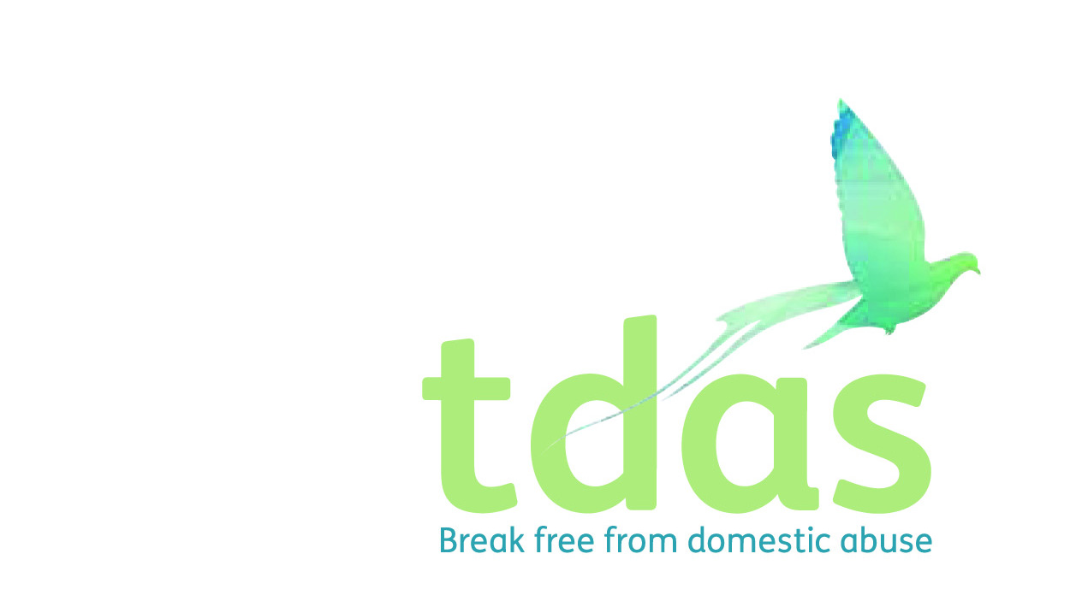

**Referral Form for Children and Young People’s Community Service**

**Completed forms can be returned via email to** [**Amy.Moss@tdas.org.uk**](mailto:Amy.Moss@tdas.org.uk)

**All referrals must be sent password protected**

**PLEASE ENSURE OUR CONFIDENTIALITY AND INFORMATION FORM IS SIGNED BY PARENT/CARER PRIOR TO THE REFERRAL BEING SENT IN**

|  |  |  |  |  |  |  |  |  |  |  |  |  |  |  |  |  |  |  |  |  |  |  |  |  |  |  |  |  |  |  |  |  |  |  |  |
| --- | --- | --- | --- | --- | --- | --- | --- | --- | --- | --- | --- | --- | --- | --- | --- | --- | --- | --- | --- | --- | --- | --- | --- | --- | --- | --- | --- | --- | --- | --- | --- | --- | --- | --- | --- |
| **Referred By:** | | | | | | |  | | | | | | | | | **Date Referred** | | | | | | | | | | | | | |  | | | | | |
| **Role:** | | | | | | |  | | | | | | | | |
| **Referral contact:** | | | | | | | Email:  Telephone: | | | | | | | | | | | | | | | | | | | | | | | | | | | | |
| **CYPS involvement?** | | | | | | |  | | | | **Level of involvement:** | | | | | | | | | | | | | |  | | | | | | | | | | |
| **Social worker details:** | | | | | | | | | | | | | |  | | | | | | | | | | |
| **Has the child & parent consented to this referral?** | | | | | | |  | | | | | | | | | | | | | | | | | | | | | | | | | | | | |
| **Please tick which Children and Young People’s Community Service you are referring to:** | | | | | | | | | | | | | | | | | | | | | | | | | | | | | | | | | | | |
| **RSPACE** |  | | | | **1-2-1** | | |  | | | | **CYP Counselling** | | | | | | | | | | |  | | | | | | **SOSN** | | | | |  | |
| **Name of Child** | | |  | | | | | | | | | | | | | | | | | | **DOB** | | | | | | | | |  | | | | | |
| **Age** | | | | | | | | |  | | | | | |
| **Current address** | | |  | | | | | | | | | | | | | | **Postcode** | | | | | | | | | | | | |  | | | | | |
| **Parent’s details** | | |  | | | | | | | | | | | | | | **Contact Number:** | | | | | | | | | | | | |  | | | | | |
| **Child’s school** | | |  | | | | | | | | | | | | | | **Safe to contact** | | | | | | | | | | | | |  | | | | | |
| **Does the child have contact with the perpetrator?** | | | | | | | | | (please specific in what capacity the contact occurs i.e. living in the same home, supervised contact, no contact) | | | | | | | | | | | | | | | | | | | | | | | | | | |
| **Perpetrators relationship to child:** | | | | | | | | |  | | | | | | | | | | | | | | | | | | | | | | | | | | |
| **Ethnicity** | |  | | | | | | | | | | | | | | | | | | | | | | | | | | | | | | | | | |
| **Child’s first language** | | | | | |  | | | | | | | | | | | | | | | | | | | | | | | | | | | | | |
| **Child’s religion** | | | | | |  | | | | | | | | | | | | | | | | | | | | | | | | | | | | |
| **Other Children in the family***If more than 3 children in family please attach their details to referral* | | | | | | | | | | | | | | | | | | | | | | | | | | | | | | | | | | | |
| **1st Childs name** | | | |  | | | | | | **DOB & age** | | | | |  | | | | | | | CP reg | | | | | | | |  | CIN | |  | | |
| **School** | | | |  | | | | | | | | | | | | | | | Childs Ethnicity | | | | |  | | | | | | | | | | | |
| **2nd Childs name** | | | |  | | | | | | **DOB & age** | | | | |  | | | | | | | CP reg | | | | | | | |  | CIN | |  | | |
| **School** | | | |  | | | | | | | | | | | | | | | | Childs Ethnicity | | | | | |  | | | | | | | | | |
| **3rd Childs name** | | | |  | | | | | | **DOB & age** | | | | |  | | | | | | | CP reg | | | | | | | |  | CIN | |  | | |
| **School** | | | |  | | | | | | | | | | | | | | | | Childs Ethnicity | | | | | | |  | | | | | | | | |
| **Other agencies involved:** | | | | | | | | | | | | | | | | | | | | | | | | | | | | | | | | | | | |
| Name & agency | | | | | | | | | | | | | | Contact | | | | | | | | | | | | | | | | | | | | | |
|  | | | | | | | | | | | | | |  | | | | | | | | | | | | | | | | | | | | | |
|  | | | | | | | | | | | | | |  | | | | | | | | | | | | | | | | | | | | | |
|  | | | | | | | | | | | | | |  | | | | | | | | | | | | | | | | | | | | | |
| **Reasons for referral:** | | | | | | | | | | | | | | | | | | | | | | | | | | | | | | | | | | | |
| Has the child been exposed to DA?  (witnessed, overheard, present in the house when DA has occurred) | | | | | | | | | | | | | **YES** | | | | |  | | | | | | | | | | **NO** | | | |  | | | |
| Please provide details of History of DA and Involvement with the family**:** | | | | | | | | | | | | | | | | | | | | | | | | | | | | | | | | | | | |
| (please provide as much information about the child’s experience of domestic abuse as possible) | | | | | | | | | | | | | | | | | | | | | | | | | | | | | | | | | | | |
| How has the child or young person been affected by the DA they have been exposed to? | | | | | | | | | | | | | | | | | | | | | | | | | | | | | | | | | | | |
|  | | | | | | | | | | | | | | | | | | | | | | | | | | | | | | | | | | | |
| Please specify what support you would like for the child or young person you are referring: | | | | | | | | | | | | | | | | | | | | | | | | | | | | | | | | | | | |
|  | | | | | | | | | | | | | | | | | | | | | | | | | | | | | | | | | | | |
| **For TDAS Staff to complete:**  R Space Programme offered:  If Yes – start date of programme:  SOSN Programme offered:  If Yes – start date of programme:  1:1 Support offered:  Please state reasons for 1:1 support:  Any other information: | | | | | | | | | | | | | | | | | | | | | | | | | | | | | | | | | | | |

**Confidentiality and Information Sharing**

Notes to referrer:

If you are having this conversation over the telephone, read through the agreement below and sign in the box over the page to say you have explained it to the client. On the first opportunity you get to see your client face to face, go through this agreement again and ask the client to sign the reverse and send to us.

**In an emergency TDAS staff will follow the following guidelines**

Our aim

* To support you in whatever choices you make
* Inform you of choices that are available to you
* To create a safe environment for you to disclose sensitive and personal information
* To respect your decisions

The information below outlines how we will treat the information that you give us about yourself, your family and others and your circumstances.

**It is important that this document is read/explained to the parents/carers of the CYP you are referring. They must then sign and print at the end of this document before the referral is sent in.**

**In an emergency**

The basic principles of confidentiality and information sharing are

1. The information you provide is confidential unless:
2. You consent to information being shared **OR**
3. You or any children are likely to be seriously injured – this will usually be called ‘at high risk of serious harm’
4. We will always try and tell you when information is being shared unless it is not safe for you or your children or if we can’t contact you.
5. If we have to share information in this situation, we will only share relevant information that will improve you and / or your child[ren’s] safety.
6. If we do not have your consent to share information, we will talk this situation through with a senior member of the team and will write on your case file what we have shared, why and who with.
7. You have a right to access your file, please contact the service which will advise you of the process.

**How will we treat any information that you give us?**

We will use information you give us to help keep you and any children safe. We will also use this information to improve the service we offer you and others.

* Generally, the information that you share with us about yourself, your family and others and your situation will be treated as confidential by TDAS. This means that only authorised people at TDAS will have access to this information unless you say otherwise.
* There may be times when it is useful for someone from TDAS to share information about you/your children with other agencies. Unless your situation is ‘high risk’ your case worker must ask for your permission to share this information and you will be able to say yes or no.
* If residing at our Refuge/Move On accommodation, Housing Options Service Trafford (HOST) will automatically be informed.

**Improving the service we offer you**

* So that we can try to improve the service we offer, we might need to make your/your childs details and information you give us anonymous so that we can share it with agencies and researchers outside of our service. This helps us to monitor our performance, understand more about domestic abuse and the best ways to improve the lives of people who experience it.
* When we share information in this way the identities of our clients and their children will never be revealed.

**You can choose if you are happy for your information to be made available for these reasons. If you decide to say no, this will in no way affect the service that you receive.**

**So that we know you have read and understood this agreement please answer yes or no to each statement by placing a cross in the box. It is important that you answer yes or no to each statement.**

|  |  |  |
| --- | --- | --- |
|  | Yes | No |
| The confidentiality and information agreement has been explained to me. |  |  |
| I give permission for anonymised information about my children to be used by other agencies and researchers for the purpose of monitoring and research. |  |  |
| I understand that information about me/my children will be held confidentially unless I give my permission for it to be shared with others. |  |  |
| I understand that there are exceptions to this and in the event that I or my children are assessed to be at high risk of harm, information about me can be shared without my permission. |  |  |

Please sign and date the agreement

|  |  |  |  |
| --- | --- | --- | --- |
| Signature |  | Date |  |
| Print name |  |  |  |

Referrer Signature

|  |  |  |  |  |
| --- | --- | --- | --- | --- |
| Agency name | Agency contact | Permission to share information | Date | Date of review |
|  |  | Y/ N |  |  |
|  |  | Y / N |  |  |
|  |  | Y / N |  |  |
|  |  | Y / N |  |  |
|  |  | Y / N |  |  |