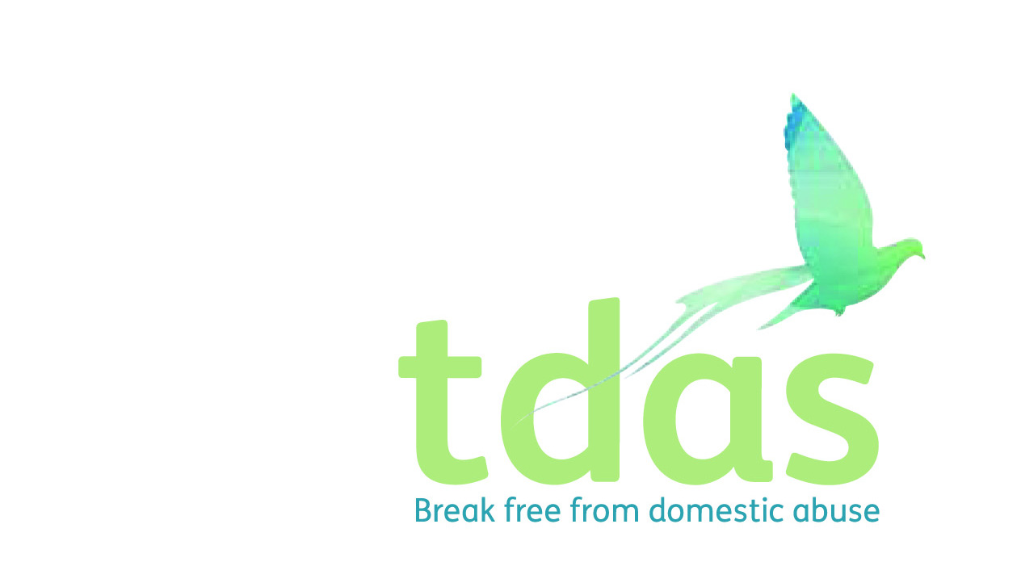

Job Title: Accommodation Service Administrator

Salary: £21,322

Benefits: A generous package including 33 days holiday per year inclusive of bank holidays (FTE), extra holidays, for long service, Employee pension scheme with 3% employer contribution (after 3 months of employment), Cycle2work Scheme, Life assurance benefit, 365 days a year Employee Assistance Programme

Location: Trafford

Closing Date: Monday 2nd August 2021

Date of Interview: Wednesday 11th August 2021

Start Date: ASAP

Hours: 37 hours per week

Contract end date: Fixed term for 12 months from start date

Background

TDAS is an independent voluntary organisation which is affiliated to Women’s Aid Federation England. TDAS and has been operating since June 1990. TDAS is a company Limited by guarantee and a registered charity.

TDAS is the only specialist agency in Trafford to deliver both intervention and prevention services to adults and children and young people who are experiencing or have experienced domestic abuse.

Purpose of the role

To provide comprehensive administrative support function to the Accommodation Service and staff team.

You will work as part of a skilled, multi-disciplinary staff team and must be approachable and highly motivated in supporting and encouraging people experiencing domestic violence/abuse to make informed choices in order to determine their own future.

Main duties

• Take responsibility for all premises matters ensuring that leases and facilities are well managed and represent value for money

• Answering the telephone and passing on accurate messages to colleagues;

• Day to day office administration for the Team leader and Accommodation staff team

• Management of stock levels and ordering within budget constraints Manage the day to day relationships with external contractors ensuring that a value for money services are maintained

To apply for this position it is essential that you have a minimum of 2 years experience of working in an administrative role and a minimum of grade C in GCSE Maths and English.

This post is subject to an enhanced DBS.

Applicants with minimum qualifications and experience will only be considered.

Please do not send CVs, as they will not be processed.

No agencies please.

For further information please contact [admin@tdas.org.uk](mailto:admin@tdas.org.uk) Tel: 0161 872 7368

An application pack is available to download from [www.tdas.org.uk](http://www.tdas.org.uk)