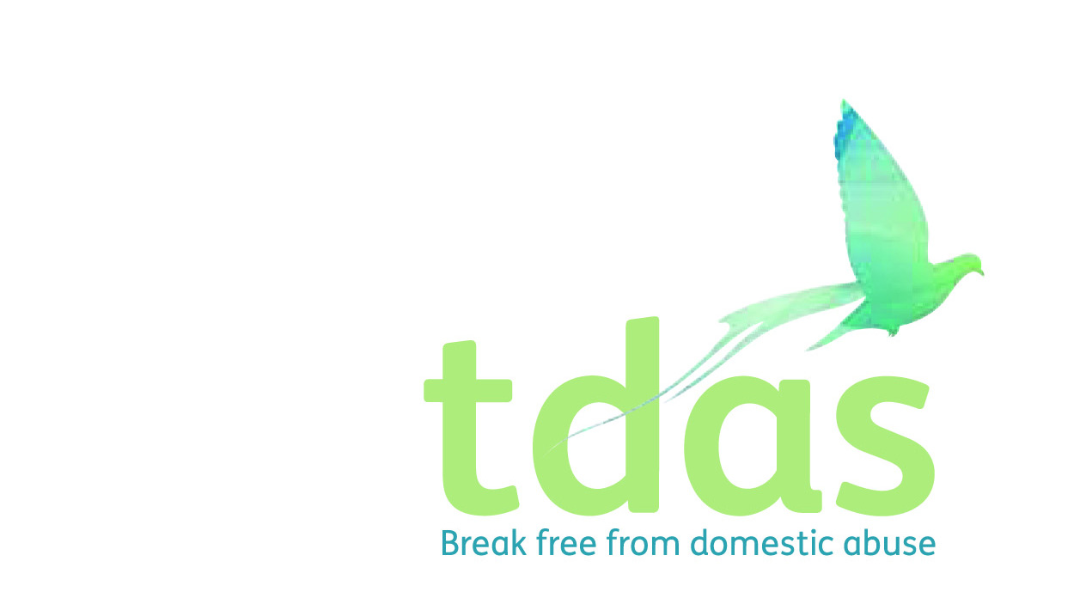

Job Title: IPS DA Advisor (Integrated Partner support)

Salary: £12,006 (FTE £24,012)

Pension: Pension scheme entitlement after 3 months of employment

Location: Manchester

Closing Date: Wednesday 5th May 2021

Date of Interview: Monday 10th May 2021

Start Date: To be confirmed with the successful applicant.

Hours: 18.5 hours per week

Contract end date: Fixed term until 31st March 2025

Background

TDAS is an independent voluntary organisation which is affiliated to Women’s Aid England. TDAS and has been operating since June 1990. TDAS is a company Limited by guarantee and a registered charity.

TDAS is the only specialist agency in Trafford to deliver services to adults, children and young people who are experiencing or have experienced domestic abuse.

**Purpose of the role**

To play an integral and active part in the community-based outreach support and community projects within Trafford.

You will work as part of a skilled, multi-disciplinary staff team and must be approachable and highly motivated in supporting and encouraging people experiencing domestic violence/abuse to make informed choices to determine their own future.

The IPS DA Advisor will work closely with CYP Support Worker and also case workers from our partner organisation, Talk Listen Change (TLC), to ensure the safety of survivors and children throughout the course of the intervention.

The role will be based within the TDAS main offices.at Gorse Hill Studios, Stretford. You will, however, be required to work from other properties and venues within Trafford.

**Main duties**

* Provide a proactive, trauma informed and person-centred approach to supporting adults who remain in abusive relationships, where their partner is accessing the appropriate intervention for abusive behaviour.
* Work closely and alongside Talk, Listen & Change as they provide the perpetrator intervention, creating a holistic support package for the couple/family.
* Supporting a minimum of 36 victims over 12-month period and providing advice and guidance to a minimum of 6 friends/family members.
* To network and liaise with all relevant agencies regarding the emotional, developmental and practical needs of adults, children and young people for whom TDAS is providing a service
* To offer practical and emotional support to service users
* To keep accurate, factual and appropriate daily recordings and record these on the case management system in a timely and professional manner

To apply for this position it is essential that you have Professional qualification in a related field such as Diploma in Domestic abuse, health and social or equivalent, a minimum of two years experience of working with adults and children and young people in a supported and enabling setting and experience of working with individuals in a crisis situation, demonstrating strong crisis management, skills and ability to cope under pressure

This post is subject to an enhanced DBS.

**Due to the nature of this role we are only able to accept female applicants. Applicants with minimum qualifications and experience will only be considered. Please do not send CVs, as they will not be processed.**

No agencies please.

For further information please contact [admin@tdas.org.uk](mailto:admin@tdas.org.uk) Tel: 0161 872 7368

An application pack is available to download from [www.tdas.org.uk](http://www.tdas.org.uk)